# RETAIL MANAGEMENT APPLICATION USING SALESFORCE

**1.INTRODUCTION**

**1.1 OVERVIEW**

**Retail management application using Salesforce is a cloud-based software solution that helps retailers to manage their sales, customer data, inventory, and other aspects of their business operations. This application is built on the Salesforce platform, which is a leading customer relationship management (CRM) tool used by businesses worldwide.**

**The retail management application allows retailers to create and manage customer profiles, track customer interactions, and monitor customer behavior to deliver personalized marketing campaigns and improve customer satisfaction. It also helps retailers to manage their inventory by tracking stock levels, creating purchase orders, and generating reports to analyze sales trends.**

**The application provides real-time insights into sales data and enables retailers to manage their sales processes efficiently. It also helps retailers to automate their sales processes, such as lead management, opportunity tracking, and sales forecasting, to streamline their operations and increase sales efficiency.**

* 1. **PURPOSE**

**The purpose of a retail management application using Salesforce is to streamline and optimize the retail operations of a business. Salesforce is a cloud-based customer relationship management (CRM) software that can be customized to meet the specific needs of retail businesses. The application can be used to manage customer data, sales, inventory, and supply chain operations, as well as to analyze data and generate reports to help businesses make informed decisions.**

**Some of the key benefits of using a retail management application using Salesforce include:**

**Improved customer engagement: With Salesforce, businesses can manage customer data, track customer interactions, and provide personalized experiences that improve customer satisfaction and loyalty.**

**Efficient inventory management: The application can help businesses track inventory levels, forecast demand, and manage replenishment, which can help reduce stockouts and improve customer satisfaction.**

**Streamlined supply chain operations: Salesforce can help businesses manage suppliers, track shipments, and optimize delivery routes, which can help reduce costs and improve efficiency.**

**Enhanced sales and marketing capabilities: The application can help businesses track sales performance, create targeted marketing campaigns, and analyze customer data to identify new opportunities for growth.**

**2.PROBLEM DEFINITION & DESIGN THINKING**

**2.1 EMPATHY MAP**

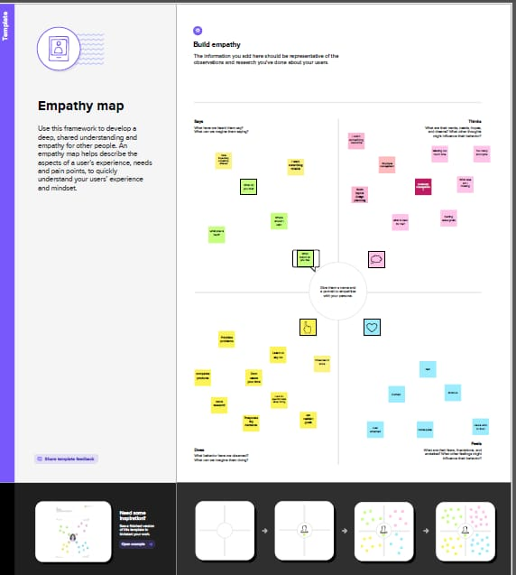

**2.2 IDEATION & BRAINSTORMING MAP**

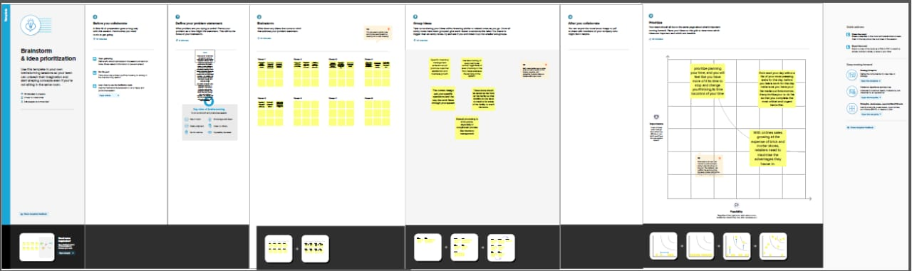

**3.RESULT**

**3.1 DATA MODEL**

|  |  |  |
| --- | --- | --- |
| **Object Name** | **Fields in the Object** | |
|  | Fields | Data Type |
| Student | Dispatched | Checkbox |
| Parent | Display/Tracking name | Test (80) |
| Dispatch Tracking | Expected date of delivery | Checkbox |
| Display Tracking | Sales order | Master - Detail |
| Warehouset | Tracking Id | Checkbox |

**3.2 Activity & Screenshot**

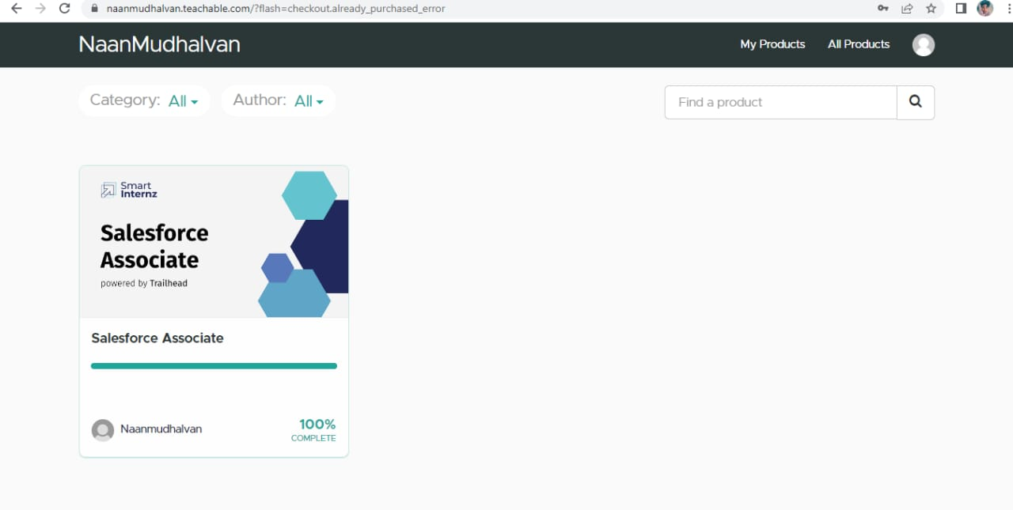

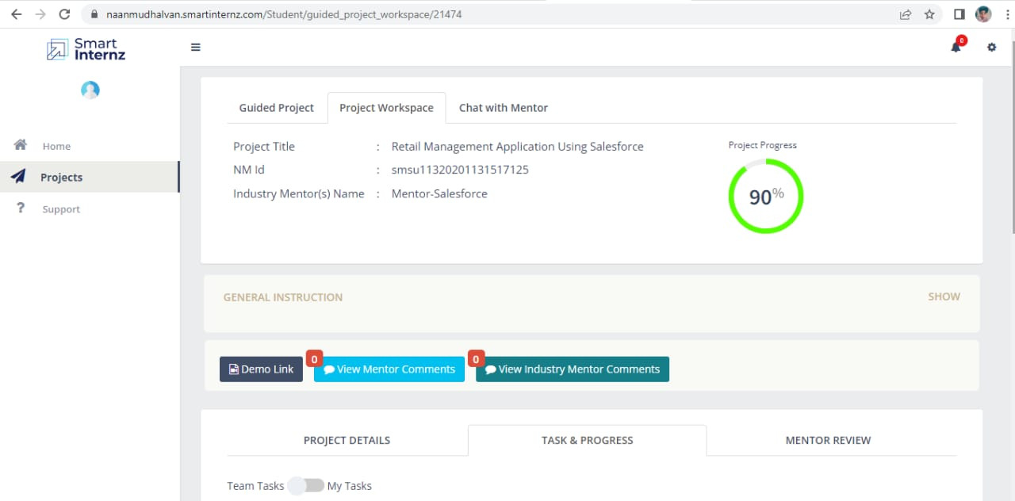

**4.TRAILHEAD PROFILE PUBLIC URL**

**TEAM LEAD -**

**[https://trailblazer.me/id/msarbudeen](/storage/emulated/0/Android/data/com.yozo.vivo.office/cache/yozoCloud/2023_04_14_17_17_40/trailblazer.me)**

**TEAM MEMBER 1 -**

**[https://trailblazer.me/id/mmathavan1](/storage/emulated/0/Android/data/com.yozo.vivo.office/cache/yozoCloud/2023_04_14_17_17_40/trailblazer.me)**

**TEAM MEMBER 2 -**

**[https://trailblazer.me/id/sanjm33](/storage/emulated/0/Android/data/com.yozo.vivo.office/cache/yozoCloud/2023_04_14_17_17_40/trailblazer.me)**

**TEAM MEMBER 3 -**

**[https://trailblazer.me/id/mathm27](/storage/emulated/0/Android/data/com.yozo.vivo.office/cache/yozoCloud/2023_04_14_17_17_40/trailblazer.me)**

**TEAM MEMBER 4 -**

**[https://trailblazer.me/id/vasai24](/storage/emulated/0/Android/data/com.yozo.vivo.office/cache/yozoCloud/2023_04_14_17_17_40/trailblazer.me)**

**5.ADVANTAGES & DISADVANTAGE**

**Salesforce is a powerful platform that provides a range of features and functionalities for retail management applications. Here are some advantages and disadvantages of using Salesforce for retail management:**

**Advantages:**

**Scalability: Salesforce is a cloud-based platform, which means it can easily scale to meet the needs of growing retail businesses. It provides a flexible infrastructure that can handle large volumes of data and users.**

**Customization: Salesforce offers a wide range of customization options that allow retailers to tailor their retail management application to their specific needs. This includes custom fields, objects, and workflows.**

**Integration: Salesforce can be easily integrated with other systems, such as inventory management, accounting, and marketing automation tools. This integration can help retailers streamline their operations and improve their overall efficiency.**

**Mobile Access: Salesforce offers mobile access, which means retailers can manage their business from anywhere. This is particularly useful for retailers who have multiple locations or are frequently on the go.**

**Reporting and Analytics: Salesforce provides powerful reporting and analytics tools that can help retailers make data-driven decisions. This includes real-time data and dashboards that provide insights into sales, customer behavior, and more.**

**Disadvantages:**

**Cost: Salesforce can be expensive, especially for small and medium-sized retailers. The platform requires a significant investment in terms of licensing, implementation, and ongoing maintenance and support.**

**Complexity: Salesforce is a complex platform that can be difficult to configure and customize without the help of a trained Salesforce developer. This can be a challenge for retailers who have limited technical resources.**

**Learning Curve: Learning how to use Salesforce can be time-consuming and requires a significant investment in training and education. This can be a challenge for retailers who have limited resources and need to get up and running quickly.**

**Security: Salesforce is a cloud-based platform, which means retailers need to be aware of the potential security risks associated with storing data in the cloud. This includes data breaches, hacking, and other security threats.**

**Dependency on Third-Party Apps: Retailers who rely on third-party apps to extend the functionality of Salesforce may be at risk if those apps become unavailable or stop working. This can impact the overall performance of the retail management application.**

**6.APPLICATIONS**

**Retail management applications using Salesforce can be used in various ways to improve the overall retail experience for customers and increase sales for businesses. Here are some common applications of retail management using Salesforce:**

**Customer Relationship Management (CRM): Salesforce is a powerful CRM tool that can help businesses manage customer data, interactions, and insights. By using Salesforce, retail businesses can gather valuable customer data, such as purchase history and preferences, which can be used to provide personalized recommendations and promotions to customers.**

**Inventory Management: Salesforce can be used to manage inventory levels, track product availability, and streamline the ordering process. With real-time inventory management, businesses can reduce the risk of stockouts and overstocking, which can negatively impact sales and profits.**

**Point of Sale (POS) Integration: Salesforce can be integrated with a variety of POS systems, allowing retailers to process transactions, manage customer data, and track inventory all in one place. This can lead to faster, more efficient transactions and a better overall customer experience.**

**Marketing Automation: Salesforce can be used to automate marketing campaigns, such as email marketing and social media advertising. By using Salesforce's marketing automation tools, retailers can send targeted messages to customers based on their preferences and behavior, which can help drive sales and increase customer loyalty.**

**Analytics and Reporting: Salesforce provides powerful analytics and reporting tools that can help businesses track sales, monitor inventory levels, and analyze customer data. This information can be used to make data-driven decisions and optimize business operations to improve profitability.**

**7.CONCLUSION**

**Salesforce is a powerful platform that can be used for retail management to enhance customer experience, streamline operations, and drive sales. By using Salesforce's suite of products such as Sales Cloud, Service Cloud, Marketing Cloud, and Commerce Cloud, retailers can manage their customer relationships, provide personalized experiences, automate marketing campaigns, and sell products across multiple channels.**

**Some of the benefits of using Salesforce for retail management include:**

**Enhanced Customer Experience: By using Salesforce's powerful tools, retailers can gain a better understanding of their customers' needs and preferences, enabling them to provide personalized experiences across multiple touchpoints.**

**Streamlined Operations: Salesforce's cloud-based platform can help retailers streamline their operations by automating tasks such as inventory management, order processing, and customer service, allowing them to focus on core business activities.**

**Improved Sales: By leveraging Salesforce's powerful analytics and reporting tools, retailers can gain insights into their sales performance, enabling them to make data-driven decisions and optimize their sales strategies.**

**Multi-Channel Commerce: With Salesforce's Commerce Cloud, retailers can sell their products across multiple channels such as online marketplaces, social media, and physical stores, providing customers with a seamless buying experience.**

**In conclusion, Salesforce is a valuable tool for retailers looking to enhance their customer experience, streamline operations, and drive sales. By leveraging Salesforce's suite of products, retailers can gain valuable insights into their customers' needs, automate tasks, and sell products across multiple channels, enabling them to compete in today's dynamic retail landscape**

**8.FUTURE SCOPE**

**Salesforce is a powerful platform for building customer relationship management (CRM) applications, including retail management applications. With its advanced features and capabilities, Salesforce offers a wide range of benefits to retailers looking to streamline their operations and improve customer experiences.**

**Here are some potential future scopes for a retail management application using Salesforce:**

**Personalized Customer Engagement: With Salesforce, retailers can create personalized customer engagement strategies based on customer data and behavior. They can offer targeted promotions, recommendations, and rewards to increase customer loyalty and retention.**

**Inventory Management: Salesforce's inventory management capabilities can help retailers manage their inventory levels, optimize stock ordering, and reduce wastage. Retailers can use Salesforce to track inventory in real-time, automate reorder notifications, and ensure that they always have the right products in stock.**

**Omnichannel Commerce: Salesforce enables retailers to offer a seamless omnichannel shopping experience to their customers. They can integrate their online, mobile, and in-store channels and provide a consistent shopping experience across all touchpoints.**

**Analytics and Reporting: Salesforce provides powerful analytics and reporting capabilities, which can help retailers gain insights into their customers' behaviors and preferences, as well as their sales and inventory data. Retailers can use this data to make informed decisions and optimize their business processes.**

**Artificial Intelligence and Machine Learning: Salesforce's AI and machine learning capabilities can help retailers improve their marketing and sales strategies, as well as automate tasks like customer support, inventory management, and personalized recommendations.**